*-- top 10 songs with the highest duration*

**select** top 10 **\*** **from** SONG_TABLE **order** **by** duration **desc**

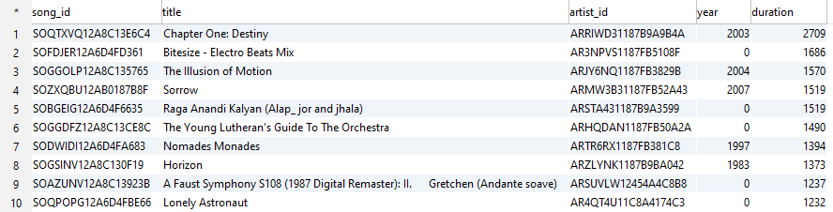

*-- top 10 songs with the least duration*

**select** top 10 **\*** **from** SONG_TABLE **order** **by** duration **asc**

;

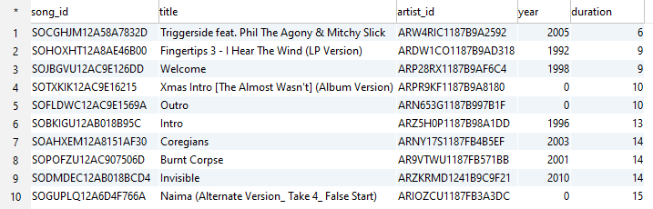

*-- group songs by year , includes songs which do not have a correct year ie categorized as 0*

**select** **year**,**count**(1) **from** SONG_TABLE

**group** **by** **year**

**order** **by** **year**

;

Returns 60 rows



*--Number of free and paid users*

**select** **level**,**count**(1) **from** USER_TABLE

**group** **by** **level**

**order** **by** **level**

;

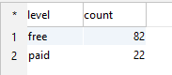

*--Gender data*

**select** gender,**count**(1) **from** USER_TABLE

**group** **by** gender

**order** **by** gender

;

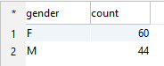

*-- top 10 songs played, with song_id, song_name and artist_name and number of times played*

**select** top 10 A.song_id,A.title,A.artist_id,C.**name**,A.**year**,A.duration, **count**(1) **as** num_times_played **from** SONG_TABLE A

**join** SONGPLAY_TABLE B

**ON** A.song_id**=**B.song_id

**join** ARTIST_TABLE C

**ON** A.artist_id**=**C.artist_id

**group** **by** A.song_id,A.title,A.artist_id,C.**name**,A.**year**,A.duration

**order** **by** num_times_played **desc**

;

